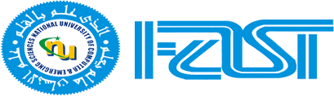

**PAKISTAN STUDIES**

**ASSSIGNEMENT 02**

|  |  |
| --- | --- |
| **Name of Student** | **Mohammad Usama** |
| **Roll No** | **20K-0190** |
| **Section** | **BS(CS) Sec-B** |
| **Submitted To** | **Sir Jehangir** |
| **Submitted By** | **Mohammad Usama** |
| **Date of Submission** | **25 Feb, 2021** |

**Contents**

**Sir Syed Ahmed Khan**

1. Introduction --------------------------------------------- 1
2. Educational Services ---------------------------------- 1
3. Utilitarian ------------------------------------------------ 1

4. Egalitarian ----------------------------------------------- 2

5. Religious ------------------------------------------------- 2

6. Impacts of Services ------------------------------------- 2

6.1 Nation Building ------------------------------------ 2

6.2 No Disloyalty -------------------------------------- 2

6.3 Educational Institute ------------------------------ 3

7. Mythology ---------------------------------------------- 3

7.1 Devotion ------------------------------------------- 3

7.2 Aloofness ------------------------------------------ 3

7.3 Loyalty --------------------------------------------- 3

**Sir Syed Ahmed Khan**

**Introduction:**-

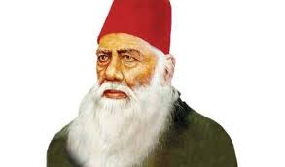Ahmad Taqvi bin Syed Muhammad Muttaqi also known as Sir Syed Ahmed Khan was born Oct 17, 1817, in Delhi. The Muslim educator, jurist and author. Founder of Muhammadan Oriental College at Aligarh.  He firmly believed that Muslim society would not progress without the acquisition of western education and science. Work hard for Human and Humanity and died on March 27, in Aligarh, India.

Figure Sir Syed Ahmed Khan

**Educational Services:**-

Sir Syed Ahmed Khan a vital role in the Educational uplift of the Muslims in India, because he was unhappy about the position of Muslims in India as their social and economic status was declining. He wanted the Muslims to benefits form British. To achieve this task he had to bring about cooperation between the Muslims and the British. To do this he did the following things:

* 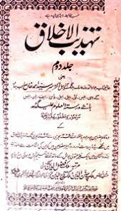Set up a journal, ***Tahzib-ul-Akhlaq*** which contained articles of influential Muslims who agreed with Sir Syed's approach towards education.

Tahzib-ul-Akhlaq

* Wrote the ***Loyal Muhammadan*** Article of India to prove, that Muslims are not disloyal to British and to ask British to end their hostility.
* Wrote a pamphlet ***Eassy on the Cause of Indian Revolt*** and pointed out the reasons for the outbreaks of 1857.
* 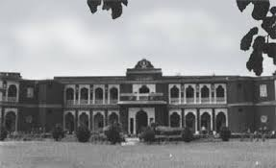Set up ***Muhammadan Oriented School*** in 24 May, 1875, Aligarh, India in 1877 it was made college and Later it was upgraded to University in 1920 named as ***Aligarh Muslim University.***
* Opened school in ***Murdabad*** in 1859.

Aligarh Muslim University in 1920

* Opened school in ***Ghazipore*** in 1864.

**Utilitarian:-**

So what Utilitarian according to Sir Syed Ahmed Khan it that Muslim and Hindus are a Single Nation. Both can eat, meet together,“*He frequently says that I see Muslim and Hindus as beautiful as the two eyes of a Beautiful bride*”. Together both Nations can beat others and this is ***One Nation Theory***.

**Egalitarian:-**

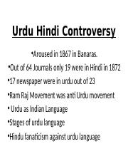Well everything is running good but in 1867 there is an issue Language Controversy occurs in Banaras. In Banaras Hindus were claiming that Hindi should be the National Language of Sub-Continent not Urdu. At that time Sir Syed Ahmed Khan said that I visited throughout the Sub-Continent and people of Sub-Continent were comfort with Urdu and easily understand that not everyone can understand Hindi but Hindus protest against Muslims then Sir Syed Ahmed Khan visualize that Muslims and Hindus are not same they are totally different from each other and they cannot live together form that Language Controversy the concept of ***Two Nation Theory*** were started.

Figure4

**Religious:-**

After the Language controversy of Banaras Sir Syed Ahmad Khan did a lot of Religious activities for Muslims. He made some School and College in sort of that Muslims get Educated and fight with West. Famous School Mohammad Oriented School Which is Now University known as Aligarh Muslim University was set up by Sir Syed Ahmed Khan. He wrote many articles so Muslims of Sub-Continent were groomed.

***Impacts of Services:***

**Nation Building:-**

After his continuous effort and hard work people were aware about the bad ideas of British. Muslims get respected and will be awarded some local ranks, so that a Nation Build and fight for their rights against British and Hindus.

**No Disloyalty:-**

As Sir Syed Ahmed Khan did a lot of hard work and make School so people can get educated and know what is wrong and what is right, what is good for them and what is bad for them, what are their rights and how to achieve them and no one can cheat them and you have to not cheat anyone and not to eat anyone’s right and not to do wrong with anyone.

**Educational Institutes:-**

Well known institute Mohammad Oriented School of Sir Syed Ahmed Khan was upgraded and people stared to go their in seek of knowledge, because they know that with the help of education they can take their rights in a proper way.

***Mythology:***

**Devotion:-**

People were devoted towards educationand have knowledge to pick what is good and what is bad for them. They are grooming day by day and because, of this British were quite sad as they declared people of Sub-Continent Uneducated but when people were getting educated and having sense so British having fear of loosing their kingdom.

**Aloofness:-**

It is that you have to aware about education and get knowledge about Politics and then came into Political before knowledge you have not to came into Politics. For this Sir Syed Ahmed Khan set up institutes and provide people the information about politics.

**Loyalty:-**

Muslim are Loyal to British and will not cheat them. This is they myth of Sir Syed Ahmed Khan that we have to make our impression on British good so they started trusting us other wise it’s difficult for us to get independent.

**The End**